The correct display of navigation lights is fundamental in avoiding collisions. You cannot be exhonorated of blame if you were not showing the correct lights at the time of the collision.
The rules for displaying navigation lights as they apply to Namadgi are:

- You must switch on the appropriate lights between sunset and sunrise and in very poor visibility.

- When under sail (diesel stopped or forward gear not engaged), you have a choice of navigation lights. You can either switch on the combined red white and green lantern (often called the tricolour), or the port and starboard sidelights and the white sternlight, but not both sets together. No other lights may be switched on. The advantages of the combined tri lantern are that it can be seen more easily and uses less electrical power.
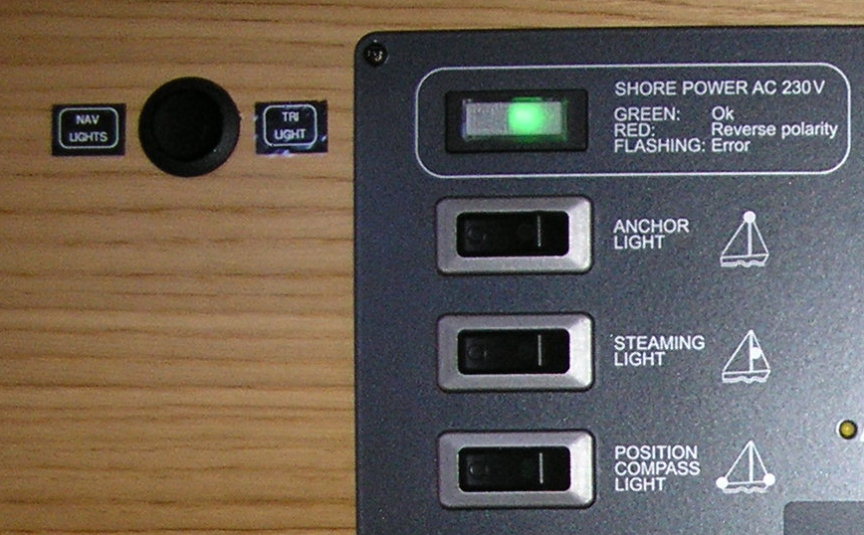
To turn the Navigation lights on:
- Switch On ‘Position Compass Light’ - main switchboard, left hand side
- Switch On Nav lights or Tri Light switch – separate switch to left of main switchboard

- When under power (propelling with the diesel, and whether or not sails are set), there is no choice. You must switch on the sidelights, the white sternlight, and the white masthead light (sometimes called the steaming light) on the front of the mast. No other lights may be switched on.

To turn these lights on:
- Switch On the Side Navigation lights as above
- Switch On Steaming light - main switchboard, left hand side

- When at anchor, and there is risk that other vessels could collide with you, switch on the all-round white anchor light at the top of the mast. No other lights may be switched on. Some jurisdictions in Queensland now enforce using the anchor light at a mooring.

To turn this light on:
- Switch On Anchor light - main switchboard, left hand side

